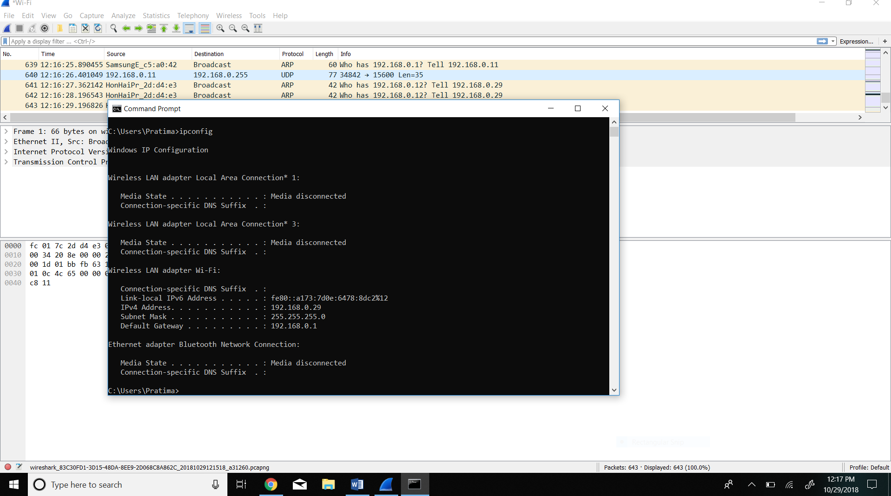

1. What is the MAC address from your computer?

The MAC address of my computer is fc:01:7c:2d:d4:e3.

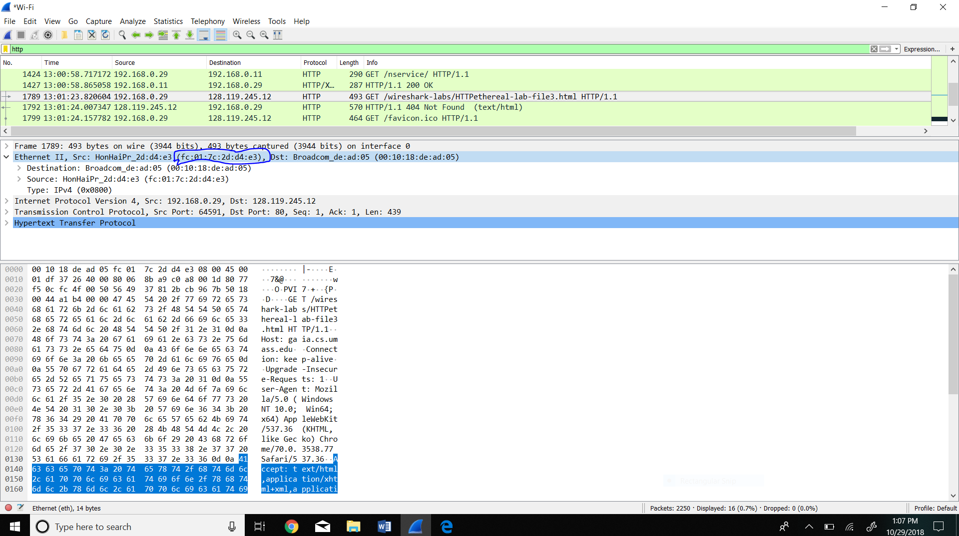

1. What is the destination MAC address?

The destination MAC address is 00:10:18:de:ad:05.

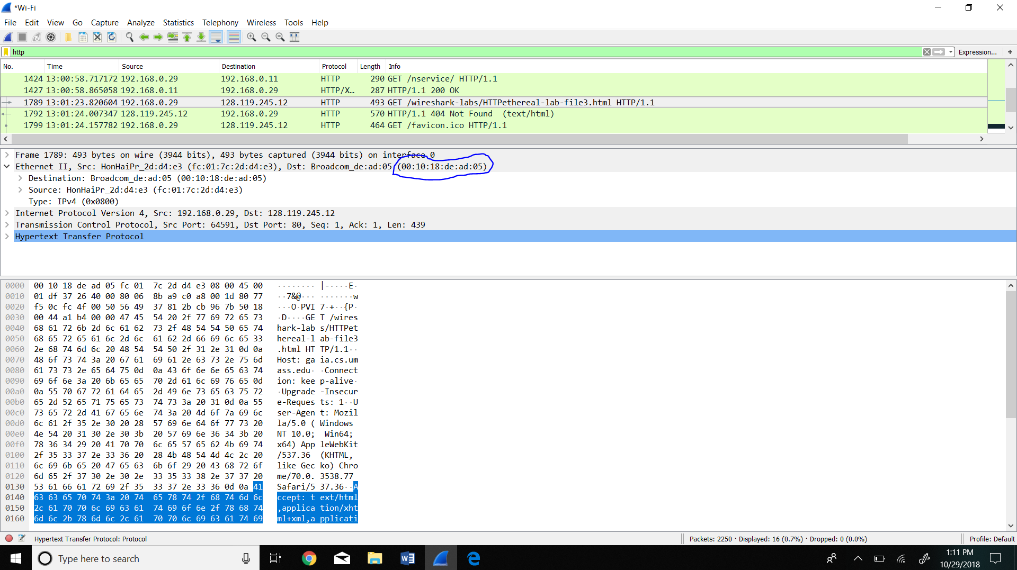

3. What device has the MAC address shown in the destination?

The device that has the MAC address shown in the destination is Broadcom.

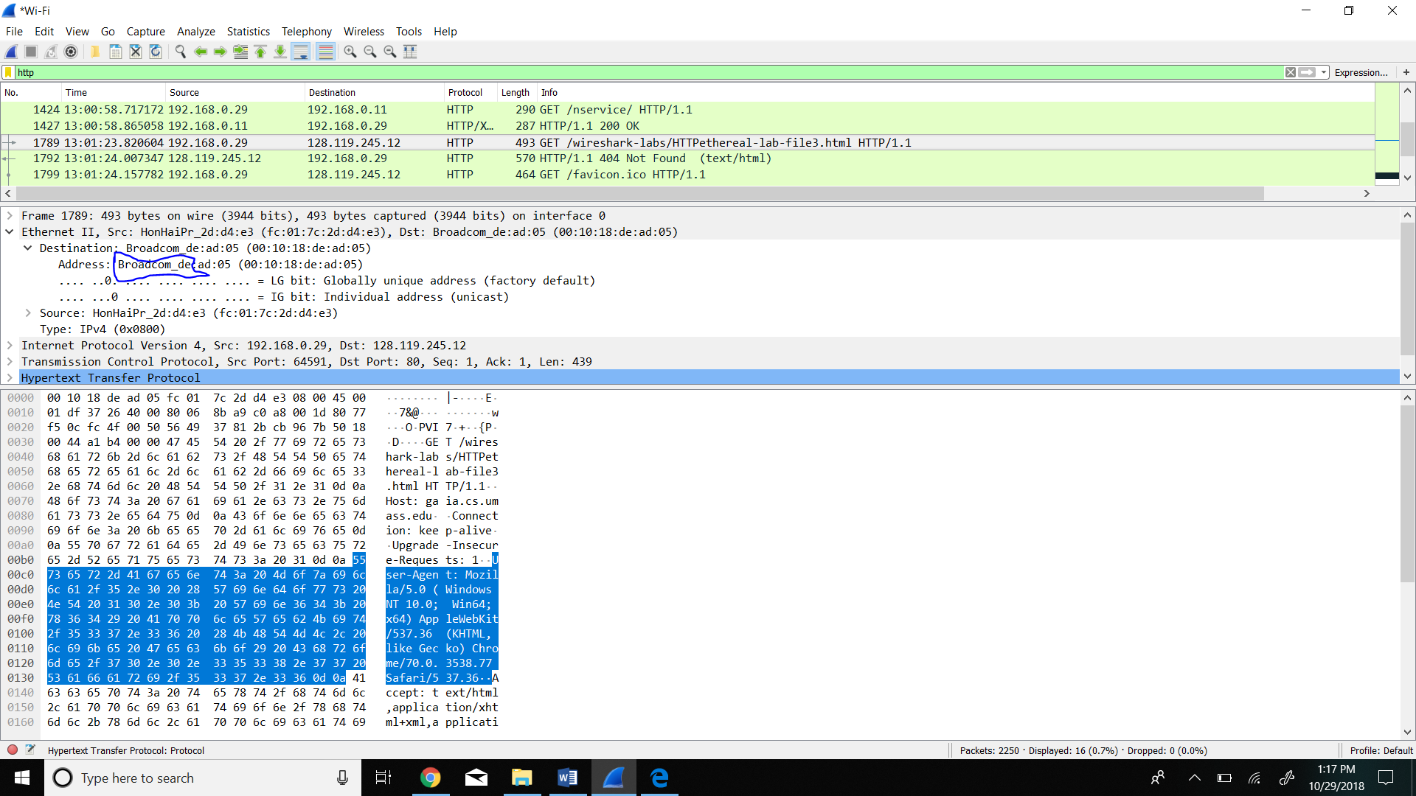

4.Explain the relationship between the destination MAC address and the destination IP address.

The destination MAC address only shows the MAC address of the router connected to the source which will later send the data to another router or the final destination. The destination IP address shows the address for the final destination rather than the middle routers.

5. Using the terminal (cmd in Windows, Terminal in mac), run a command to display your full ARP list table. (Find out what the command is, and print a full screen shot of your computer.

